Newton’s Second Law
Incline

Equipment

Dell Laptop Computer
AC Adapter, Dell Laptop
Air Track, Pasco SF-9214
Air Supply, Pasco SF-9216
Mass & Hanger Set, Pasco ME-8967
Jack, Table Silver
Air Track Accessory Kit, Pasco SF-9295
Glider, for Air Track Pasco SF-6306
LabQuest Mini, Vernier LQ-MINI
Ring Stand, Miniature
String, Box Assorted (in drawer)
Photogate, Pasco VPG-DG
Scale, Digital Sartorious BP-6100

Figure 1 – Typical Setup

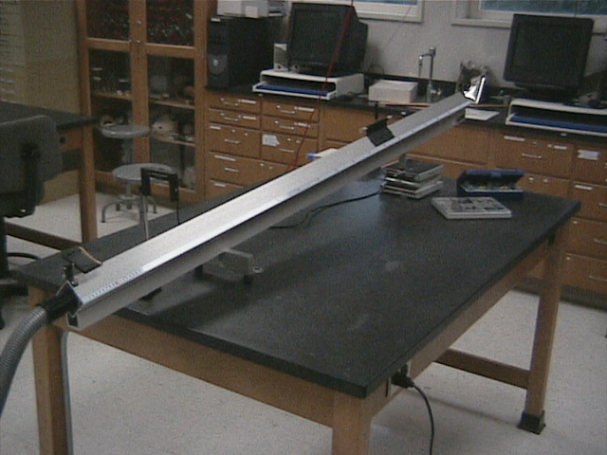

Overview
We will compare measurements of the force on an object (glider) moving down an incline versus the acceleration the object. We will then use this comparison to find the mass of the glider and compare it to the directly measured value.
Introduction
Newton’s 2nd Law of motion states that the net force on an object is proportional to its observed acceleration. The proportionality constant in this equation is the mass of the object that accelerates.
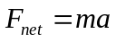 Equation 1
In this lab you will use a pulley and mass assembly to measure the force on your glider as you tilt the air-track at different angles. After each measurement of the force, you will allow the glider to accelerate down the air-track for one meter, and measure its velocity at the end of the meter traveled. From this velocity measurement you can calculate the acceleration of the glider using the kinematic equation:
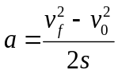, Equation 2
where:
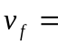 final velocity
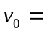 initial velocity = 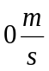
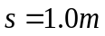 in our setup
Accuracy
All of your observations should be recorded to three significant figures. You should carry three significant figures in all your calculations as well.
Procedure
- Prop the air-track at a small angle using the table jack. Place the photogate near the lower end of the air track. Set the photogate at the proper height so that it will record the passing flag without contact. Note the location of the photo gate and the release point 1 meter up the track. These points should remain the same through all of your ‘runs.’ (Reference Figure 1.)
- With the air on, suspend the glider using a string over the pulley with masses on the hanger. (Reference Figure 2 .) Record the force needed to ‘hold’ the glider in a static position.

Figure 2
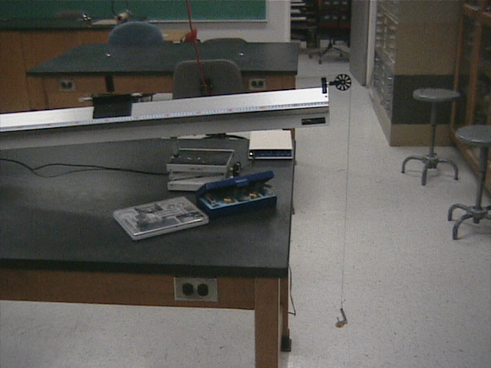

- Now move the glider to the designated release point. Since the flag is located in the center of the glider, it will give the velocity of the glider at approximately that point. We will use the center of the glider to line up at the release point as well. Record the velocity after the glider has passed through the photogate.
- Repeat Steps 2 and 3 four times using progressively higher angles. A single turn or so of the jack should be sufficient.
- Find out the mass of the glider using the electronic scale. It should not have changed during the experiment.
Analysis
- Make a graph of Force vs. Acceleration. On the graph be sure to include
- The best fit line. (Trend line in Excel©.)
- The slope and R² mean equations of the line.
- Include the point (0, 0).

Data
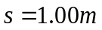
Run #  (Change jack position) | Mass  (kg) | Force  (N) |  | Velocity ()  Logger Pro | Acceleration  ()
0 (level) | 0 | 0 |  | 0 | 0
1
2
3
4
5

Questions
Remember: The force that holds the glider, when removed, equals the force that accelerates the glider.
- What does the slope of your trend line mean?
- What is its value? (Don’t forget units.)
- What is the electronic balance value for the mass?
- Which determination of mass is more reliable? Why?
- What is the percent error?

